1. JSM Supports two types of **Messaging Models**
   1. Point to Point.
   2. Publish/Subscriber
2. **Point to Point**:
   1. Also known as P2P Messaging.
   2. it allows us to send/receive msgs **synchronously and asynchronously** through **virtual channels** called **Queue**.
   3. JSM Providers allow us to create these virtual channels (Queues) and then we can put our msgs on those queues and other apps can consume from there.
   4. The only distinguishing feature of P2P Messaging is that the msg that is put on to the Queue is consumed only once or by only one app.  
      Once it is consumed it is gone from the Queue which is the responsibility of the JSM provider. 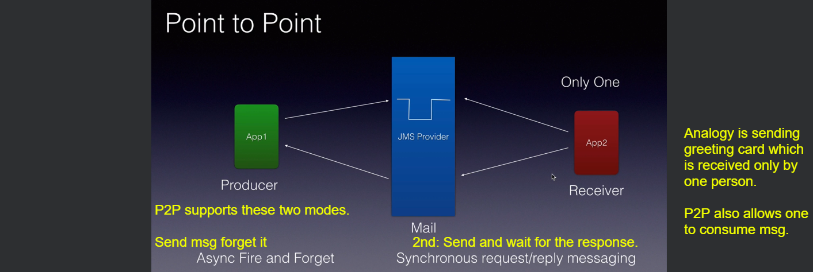
3. **Publish/Subscribe**:
   1. Another way of messaging.
   2. Also known as Pub/Sub Messaging.
   3. 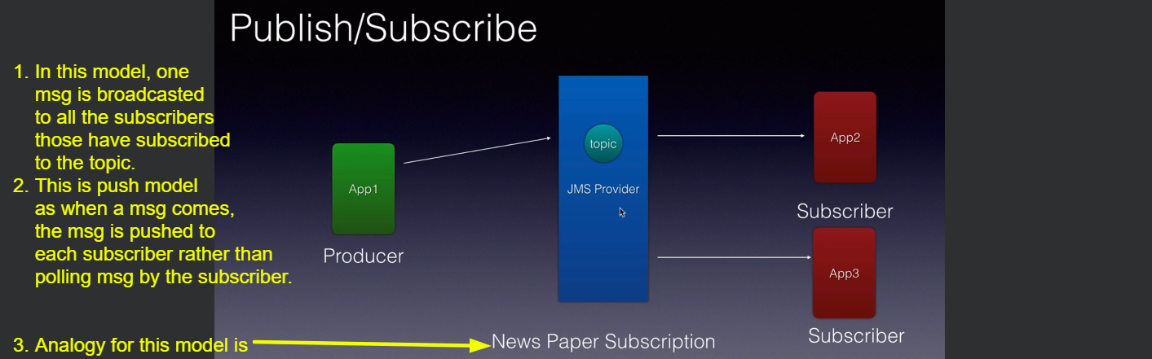
4. We will be creating both Queues and Topics.